EX14-Create a Snapshot of a VM and Test it by loading the Previous Version/Cloned VM

PROCEDURE:

Step1: create a virtual machine with particular configuration and take a snap shot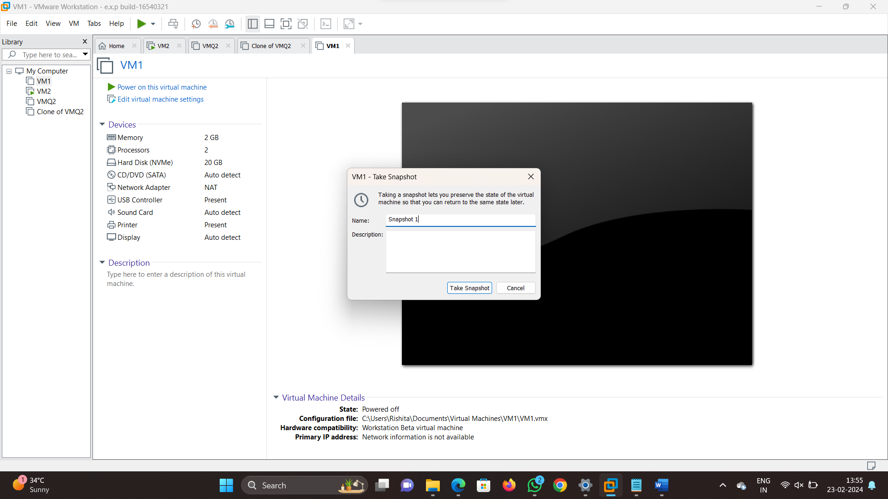

Step2:Now the configuration should be changed and then take a snapshot

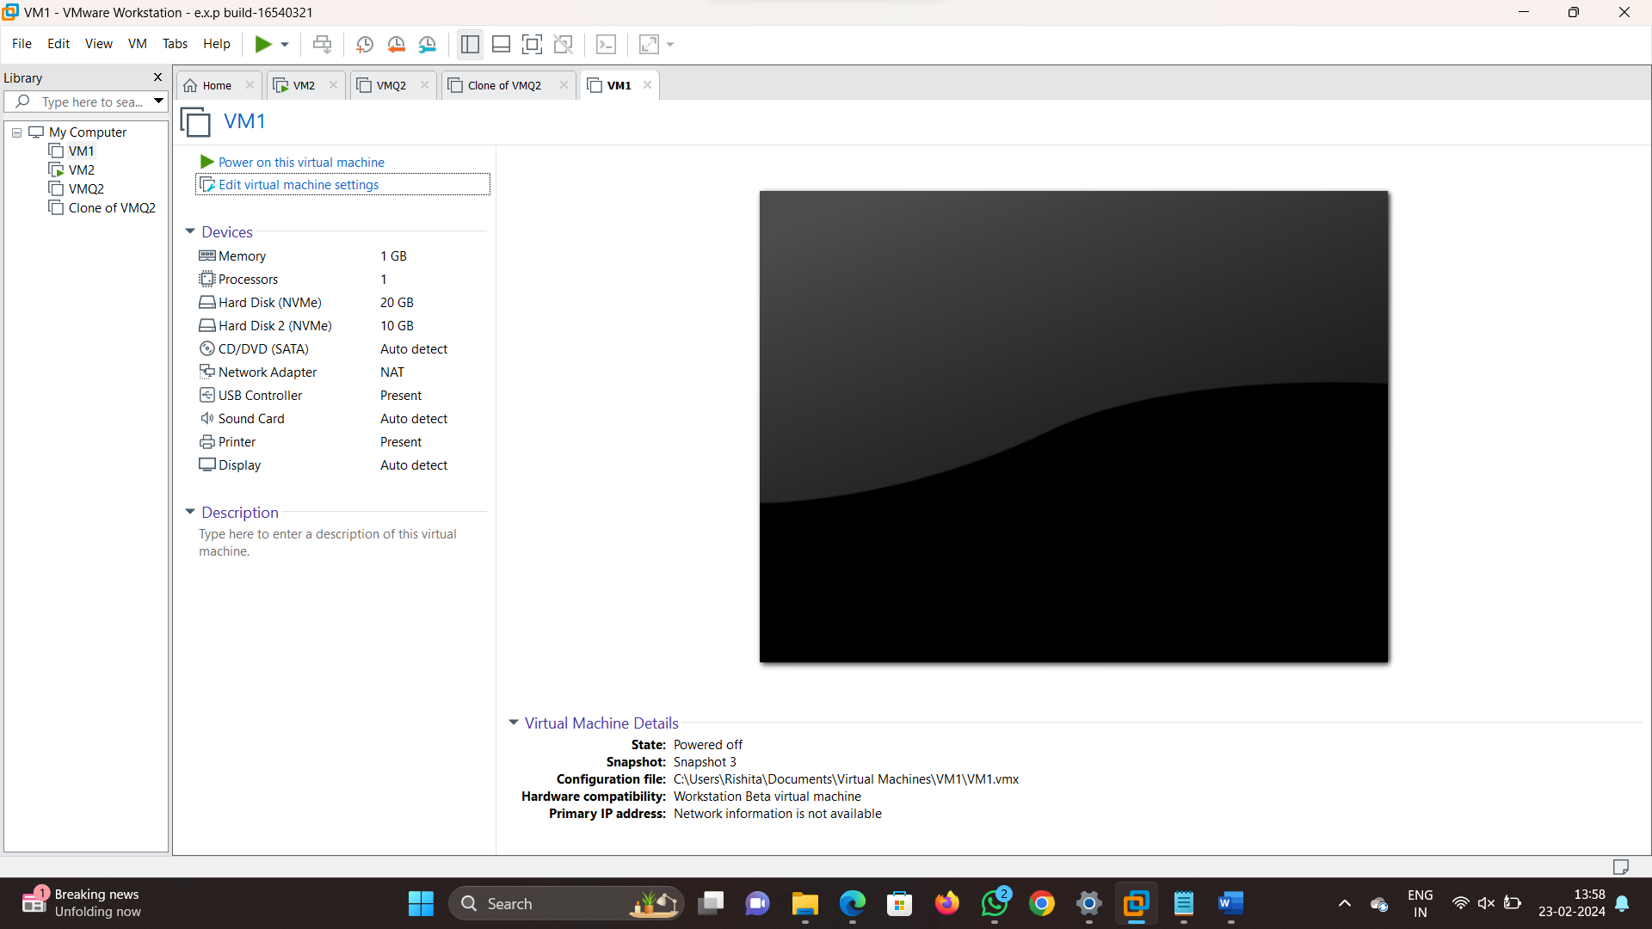

Step3: similarly take snap shot of different configurations

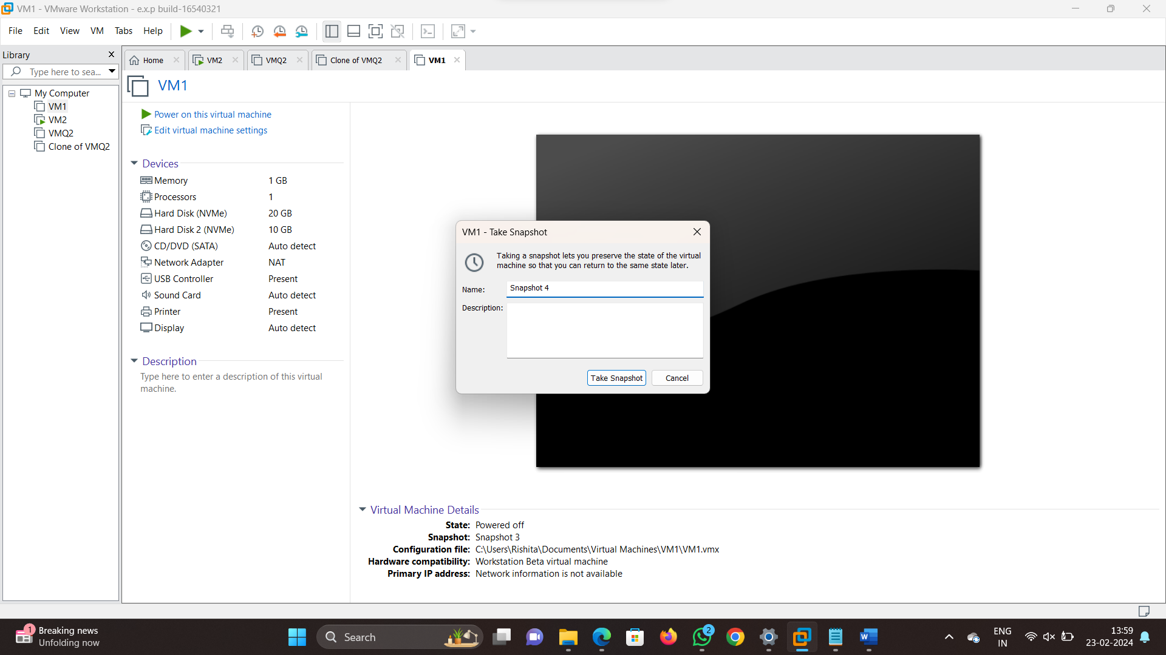

Step4: Now go to VM and go to snapshot manager and click on it

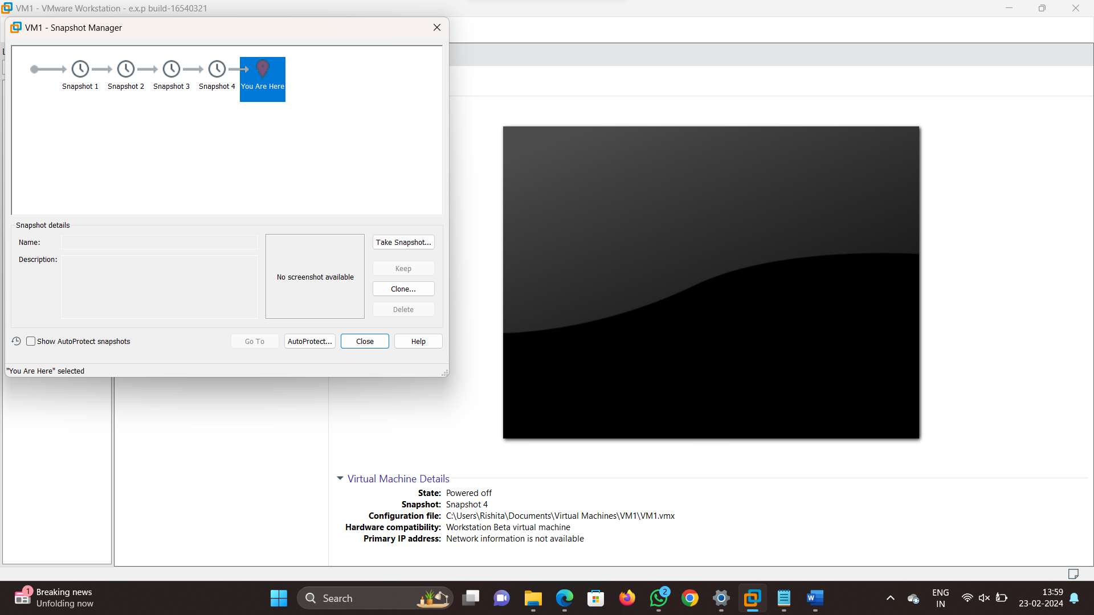

Step 5: To restore the previous vm we need to click on a particular snapshot and click on yes

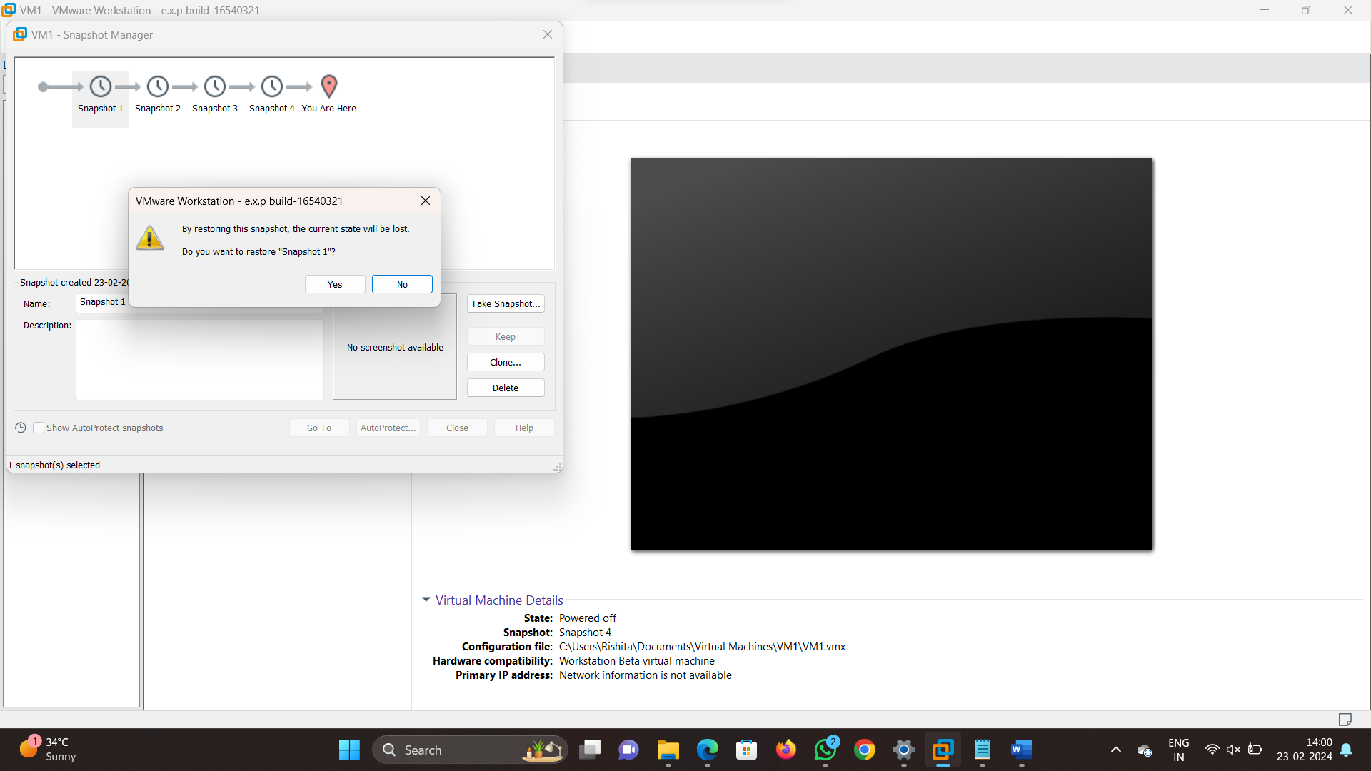

Step 6: now the particular virtual machine is displays by restoring

